OS LAB
Pratical-8
- Develop a program using malloc(), calloc(), realloc(), and free(). Monitor memory allocation behavior and identify memory leaks using Valgrind.

Develop a program that demonstrates Copy-on-Write behavior after a fork(). Analyze memory usage before and after modifying data in the child process.

main.c
#include <stdio.h>
#include <stdlib.h>
int main() {
// 1. malloc()
int *a = (int *)malloc(5 * sizeof(int));
if (a == NULL) {
printf("malloc failed\n");
return 1;
}
for (int i = 0; i < 5; i++) {
a[i] = i + 1;
}
printf("malloc: ");
for (int i = 0; i < 5; i++) {
printf("%d ", a[i]);
}
printf("\n");
// 2. calloc()
int *b = (int *)calloc(5, sizeof(int));

if (b == NULL) {
printf("calloc failed\n");
free(a);
return 1;
}
printf("calloc: ");
for (int i = 0; i < 5; i++) {
printf("%d ", b[i]);
}
printf("\n");
// 3. realloc()
a = (int *)realloc(a, 10 * sizeof(int));

if (a == NULL) {
printf("realloc failed\n");
free(b);
return 1;
}

for (int i = 5; i < 10; i++) {
a[i] = i + 1;
}

printf("After realloc: ");
for (int i = 0; i < 10; i++) {
printf("%d ", a[i]);
}
printf("\n");
// 4. free()
free(a);
free(b);
printf("Memory freed successfully.\n");
return 0;
}

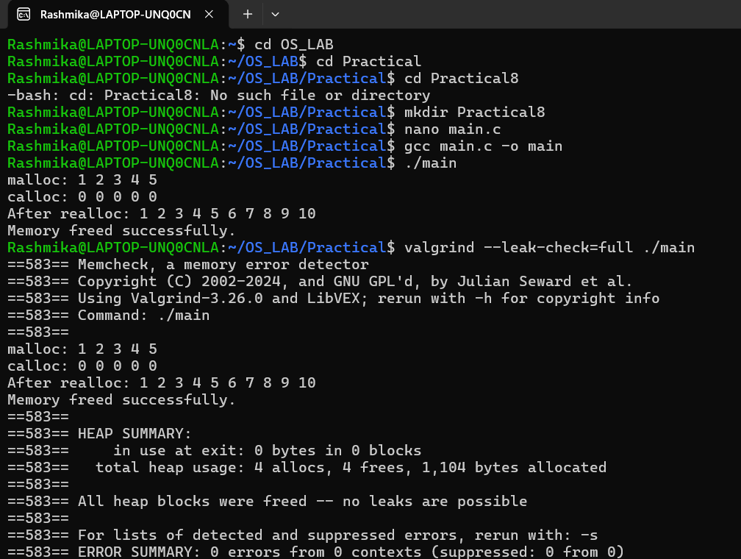

Remove : free(a);free(b)

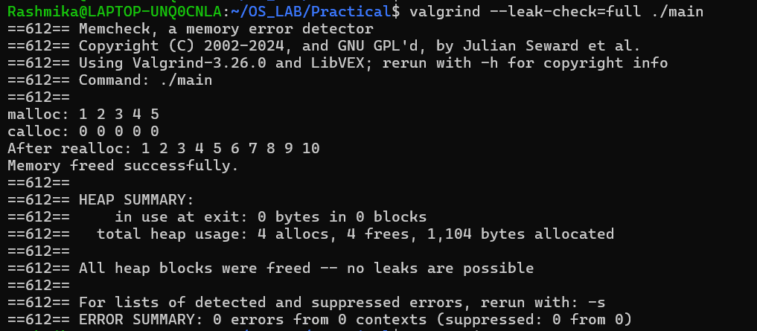

main2.c

#include <stdio.h>
#include <stdlib.h>
#include <unistd.h>
#include <sys/wait.h>

#define SIZE 1000000

int main() {

int *data = malloc(SIZE * sizeof(int));

if (data == NULL) {
perror("malloc");
return 1;
}

// Initialize memory
for (int i = 0; i < SIZE; i++) {
data[i] = i;
}

printf("Before fork: PID = %d\n", getpid());
printf("data address = %p\n", (void *)data);

pid_t pid = fork();

if (pid < 0) {
perror("fork");
free(data);
return 1;
}

if (pid == 0) {

// Child process
printf("\nChild process: PID = %d\n", getpid());
printf("Child data address = %p\n", (void *)data);

printf("Before modification: data[0] = %d\n", data[0]);

// Modify data
data[0] = 9999;

printf("After modification: data[0] = %d\n", data[0]);

sleep(5);

free(data);
exit(0);

} else {

// Parent process
printf("\nParent process: PID = %d\n", getpid());
printf("Parent data address = %p\n", (void *)data);

sleep(2);

printf("Parent data[0] = %d\n", data[0]);

wait(NULL);

free(data);
}

return 0;
}

